
January 2023

Newsletter

South West Shropshire Gardening Club

Happy New Year to you all. I hope you have enjoyed and recovered from all the festivities and are ready to engage with your garden once again. I have a little patch of snowdrops nodding cheerily outside my patio door – a sign of joyful things to come.

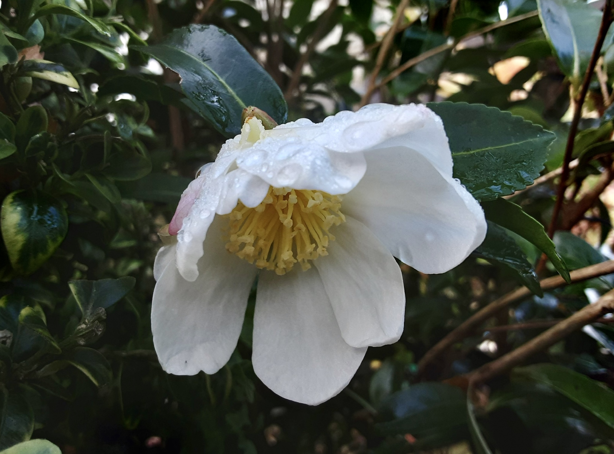

Thanks to Helen Brown for sending me this beautiful picture of one of her camellias which she grows in pots. It is the highly scented, Autumn flowering sasanqua Narumi – Gata. If anyone else has a favourite bloom or view of their garden feel free to send it to me to share in this letter.

Teas
I am really pleased that we have been able to reinstate the social cuppa at the beginning of our meetings (from 7-7.25). So far we have volunteers for Jan, Feb and Mar so a huge thank you to those people. I must remember to put the rota on the table as you arrive at the meeting so more volunteers can sign up for the future. Don’t worry if you are not sure of your commitments – we can always rearrange nearer the time if there is a problem. It only involves coming a few minutes early (about 6.45) to set out the crockery – the committee bring the supplies of tea, coffee, sugar, milk and biscuits. We will also put on the urn and dishwasher to heat up. The latter can be set off when the speaker has finished and only takes three minutes. There are easy to follow instructions on the front of the machine and help is at hand if necessary.

Newsletters
You will have realised that the way you access our newsletters has changed. Now you receive a monthly notification that the newsletter is ready to read on the website – you just have to click on the link. If there are any problems please let me know. We will aim to send the notification about a week before the meeting so news is fresh in your mind. You will also be in the right place to look at the website – if you have any contributions or suggestions that may be of interest, please let me know.

Next meeting

Wednesday 25th January

The Many Facets of Compost

In 1987 Dr Wolfgang Schaefer and Kingsley George moved from Sussex, to Cwm Weeg in Montgomeryshire. Within a few years major landscaping and gardening projects were undertaken and there has hardly been a period over the last 30 years without ongoing building work. These projects included various terraces, a fountain, 4 ponds, grotto, moss garden with rock face and stumpery. More recently a Garden Pavilion has been built with a visitor cafe. Today, Cwm Weeg comprises a formal garden of just under 3 acres, surrounded by 21 Acres of woodland and wild flower meadows, all open at regular intervals in the summer months.

In his talk on 'The Many Facets of Compost', Dr Wolfgang Schaefer will guide us through some of the origins of our present ideas on compost and give some practical tips on how to achieve success in the art of compost making.

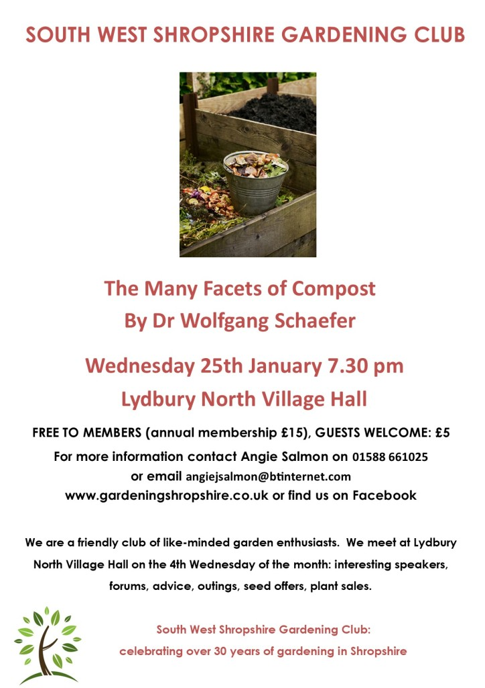

Seeds
Many thanks to Sandy for co-ordinating all our seed orders. They will be ready to collect at our next meeting on January 25th and you should have received an email to inform you of this.

Moving forward, Sandy would like someone else to take on this task in the future. If you might be interested in giving a hand, please talk to Sandy or me. It is only once a year and you wouldn’t have to be on the committee!

Membership
If you would like to join the club, you can come along to a meeting at Lydbury North Village Hall and give your details and payment to our Membership Secretary Sandra Bailey, who sits at the door ready to greet everyone. Alternatively, you can pay by transfer, using the details below. Please ensure you email your name, address and phone number to Sandy.
£15 covers attendance to all our meetings for a year; early access to trips and events with subsidised tickets; seed offers and plant sales. We are also affiliated to the RHS. Such a bargain!

Payment can be made with cash or cheque at our meetings or by transfer to:
South West Shropshire Gardening Club
sort code 20-53-22
account number 80754803.
Please add your name as reference and email sandy_burton@btinternet.com to let her know.

RHS affiliation

As mentioned above, the club is affiliated to the RHS. We receive the monthly magazine which can be borrowed, as well as back numbers. These are available from the table at the back of the hall where we display other items of interest and news.

Also, we have a discount card which can be used by up to two members of the club to gain 50% off entry to any RHS garden.

That’s all for this month. I look forward to seeing you at our meeting on 25th. It should be really interesting and helpful – you can never have too much compost! Please bring a single cut bloom or spray from your garden, if you would like to join in The Flower of the Month Competition. It doesn’t have to be exotic – all I can think of in my garden is a snowdrop!

