
February 2023

Newsletter

South West Shropshire Gardening Club

Welcome to the second newsletter of the year. So far, I am very happy with February: no storms (remember Ciara and Dennis this time in 2020?); crisp, frosty, blue sky mornings and no flooding! If you look carefully, signs of Spring are all around – they tend to be small and low level which suits me being five feet three. The stunning cyclamen below are in a garden in Clunton (up the road opposite the pub). I have watched them spreading along the brook over the last ten years and they always make me smile.

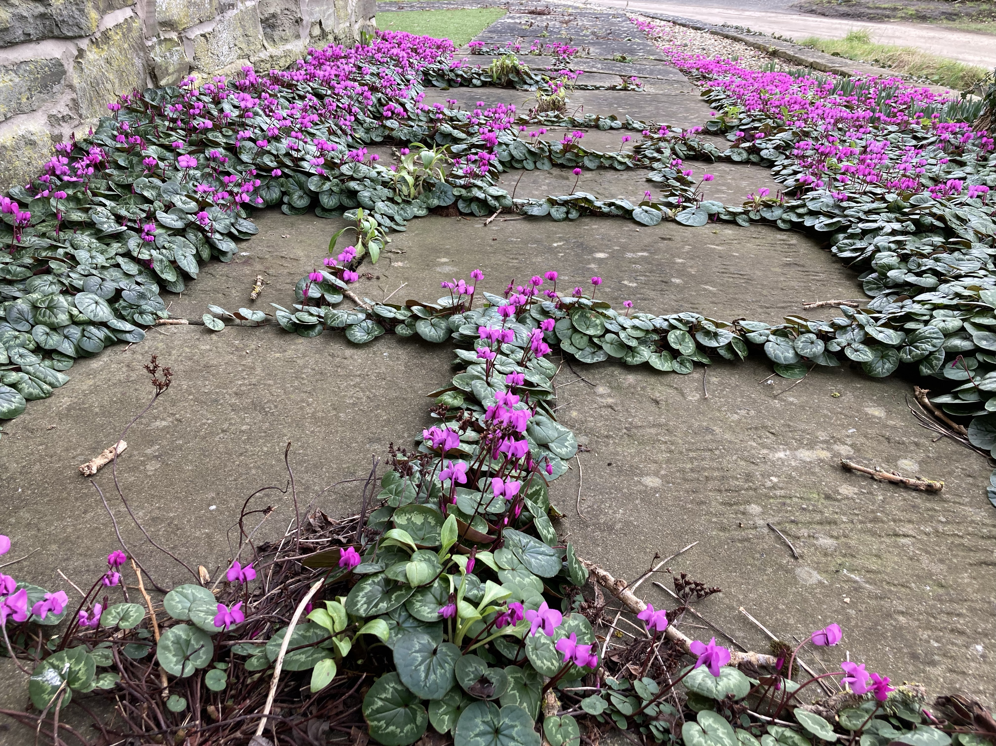

Teas
I am really pleased that we have been able to reinstate the social cuppa at the beginning of our meetings (from 7-7.25). We have volunteers for Feb and Mar so a huge thank you to those people. Please sign up on the rota as you come in so we can continue our refreshments. Don’t worry if you are not sure of your commitments – we can always rearrange nearer the time if there is a problem. It only involves coming a few minutes early (about 6.45) to set out the crockery – the committee bring the supplies of tea, coffee, sugar, milk and biscuits. We will also put on the urn and dishwasher to heat up. The latter can be set off when the speaker has finished and only takes three minutes. There are easy to follow instructions on the front of the machine and help is at hand if necessary.

Newsletters
You will have realised that the way you access our newsletters has changed. Now you receive a monthly notification that the newsletter is ready to read on the website – you just have to click on the link. If there are any problems please let me know. We will aim to send the notification about a week before the meeting so news is fresh in your mind. You will also be in the right place to look at the website – if you have any contributions or suggestions that may be of interest, please let me know.

History of the Club
One of our previous committee members, Brenda Jones, recently sent me information about how the club started in 1987. It was really interesting and made me think it would be nice to record these memories on the website, before they are forgotten or lost. If anyone has stories or photos from the past, please send them to me so we can record and share them.

NGS Shropshire
I always feel cheered when NGS starts opening gardens again for us to enjoy.

Millichope Park : Sunday 19th Feb, 2-5pm
Historic landscape gardens of 14 acres, including lakes, cascades, woodland walks and wildflowers. Snowdrops are a glorious feature in February.

The Wildegoose Nursery is within the walled garden. Laura Willgoss from the nursery is coming to visit us on 22nd March to talk about creating beautiful borders.

Powys NGS Newsletter
Online talks are available, including “Gardening in the Dolfor Hills” by Dr Wolfgang Schaefer, who talked to us about compost in January. This talk is about how his garden was created and how it has changed over the 35 years that he and Kingsley have been at Cwm Weeg.

Next meeting

Wednesday 22nd February

Aeonium: A Succulent Passion – a talk by Mellie Lewis (as seen on Gardeners’ World)

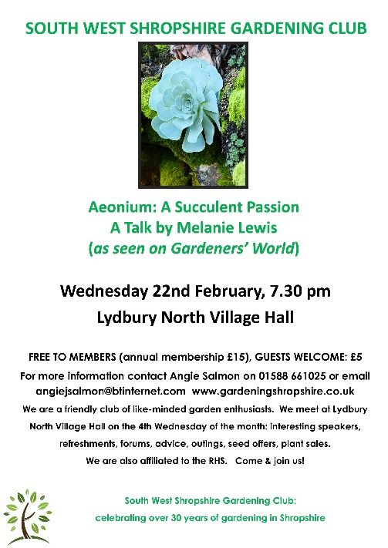

The speaker for February is our very own Mellie Lewis. Aeonium expert- last seen on Gardeners World talking about her extensive collection! So this month I have asked Mellie to describe her talk in her own words. Definitely a meeting not to be missed!
‘I have been growing Aeoniums for over 35 years, my passion started when I saved a plant from a compost heap at a garden/ nursery I was working at in the New Forest, I’d never seen anything like it before and I was hooked at first glance! In 2019 I became the National Collection holder the first ever in the U.K. for this particular genus! I have taken my plants to shows winning Silver Gilt at Hampton Court Palace flower.
Aeoniums have taken me to places I never dreamed I could visit and I’m totally hooked on finding Aeoniums in habitat and making detailed botanical records, there is still so much to learn about this little-known genus of plant.
In the talk I’ll take you to the Canary Islands to explore their beautiful habitat and explain how this incredible group of plants are some of the most threatened on the planet!’

Membership
If you still need to update your membership, you can come along to a meeting at Lydbury North Village Hall and give your details and payment to our Membership Secretary Sandra Bailey, who sits at the door ready to greet everyone. Alternatively, you can pay by transfer, using the details below. Please ensure you email your name, address and phone number to Sandy.
£15 covers attendance to all our meetings for a year; early access to trips and events with subsidised tickets; seed offers and plant sales. We are also affiliated to the RHS. Such a bargain!

Payment can be made with cash or cheque at our meetings or by transfer to:
South West Shropshire Gardening Club
sort code 20-53-22
account number 80754803.
Please add your name as reference and email sandy_burton@btinternet.com to let her know.

RHS affiliation

As mentioned above, the club is affiliated to the RHS. We receive the monthly magazine which can be borrowed, as well as back numbers. These are available from the table at the back of the hall where we display other items of interest and news.

Also, we have a discount card which can be used by up to two members of the club to gain 50% off entry to any RHS garden. Please ask me to borrow the card if you are planning a trip to an RHS Garden.

Plant Hunters’ Fairs

Rather than going to pricey garden centres with limited variety on offer, these fairs are well worth a visit (or several!)
The plant fairs bring together some of the best independent plant nurseries from across the country with a brilliant choice of plants to delight every gardener. The entrance charges on these special days are such good value, often up to half the standard garden entry price.

The fairs are also valuable fundraisers for our venues and every penny of the entrance fees goes to the venues to help them keep going after these tough times.

These fairs and gardens also make a great destination for group outings.

Plant Hunters’ Fairs 2023

March
Sunday 19 Southwell Minster, NG25 0HD 11am-4pm Plant Fair £2.00 NEW SPRING FAIR
Saturday 25 Sugnall Walled Garden, Eccleshall ST21 6NF 10am-4pm Gardens & Fair £1.00
Sunday 26 Arley Hall, Northwich, CW9 6NA 10am-4pm Plant Fair £2.00

April
Saturday 1 Bodenham Arboretum, Kidderminster DY11 5TB 10am-4pm Free Entry to Fair
Sunday 2 Ness Botanic Gardens, Wirral, CH64 4AY 10am-4pm Plant Fair £1.00
Good Friday 7 Whittington Castle, Oswestry, SY11 4DF 10am-4pm Plant Fair & Castle Grounds Free Entry (P&D Parking)
Easter Sunday - Monday 9 - 10 Dorothy Clive Garden, Market Drayton TF9 4EU 10am-5pm Gardens & Fair £5.00
Sunday 16 Middleton Hall, Tamworth B78 2AE 10am-4pm Gardens & Fair £3.50 TICKET REQUIRED
Saturday 22 1620s House, Donington Le Heath, LE67 2FW 10am-4pm Gardens & Fair £1.00 TICKET REQUIRED
Sunday 23 Cholmondeley Castle, Malpas, SY14 8AH 10am-5pm Gardens & Fair £5.00
Sunday - Monday 30 April - 1 May Weston Park, Shifnal TF11 8LE 10am-4pm Gardens & Fair £4.00 TICKET REQUIRED*

May
Saturday 13 Battlefield 1403, Shrewsbury, SY4 3DB 9:30am-4pm Free Entry Returns after 3 years
Sunday 14 Capesthorne Hall, Macclesfield SK11 9JY 10am-4pm Gardens & Fair £4.00
Sunday 21 Norton Priory, Runcorn, WA7 1SX 10am-4pm Plant Fair £1.00
Saturday 27 Carsington Water, Ashbourne DE6 1ST 10am-4pm Country Park & Fair Free Entry (P&D Parking)
Monday 29 Arley Arboretum, Upper Arley, Worcs DY12 1SQ 10am-4pm Free Entry to Fair

June
Saturday - Sunday 10 - 11 Hodnet Hall, Market Drayton TF9 3NN 10am-5pm Gardens & Fair £5.00
Saturday 17 Sugnall Walled Garden, Eccleshall ST21 6NF 10am-4pm Gardens & Fair £1.00 NEW SUMMER FAIR
Sunday 25 Middleton Hall, Tamworth B78 2AE 10am-4pm Gardens & Fair £3.50 TICKET REQUIRED

July
Saturday 1 Thoresby Park, Newark NG22 9EQ 10am-4pm Plant Fair & Country Park Free Entry (P&D Parking)
Sunday 2 Whittington Castle, Oswestry, SY11 4DF 10am-4pm Plant Fair & Castle Grounds Free Entry (P&D Parking)
Sunday 30 1620s House, Donington Le Heath, LE67 2FW 10am-4pm Gardens & Fair £1.00 TICKET REQUIRED

August
Wednesday 2 Cholmondeley Castle, Malpas, SY14 8AH 10am-5pm Gardens & Fair £5.00 SPECIAL MIDWEEK DATE
Sunday 6 Southwell Minster, NG25 0HD 11am-4pm Plant Fair £2.00
Sunday 13 Capesthorne Hall, Macclesfield SK11 9JY 10am-4pm Gardens & Fair £4.00
Sunday 20 Carsington Water, Ashbourne DE6 1ST 10am-4pm Country Park & Fair Free Entry (P&D Parking)
Sunday - Monday 27 - 28 Dorothy Clive Garden, Market Drayton TF9 4EU 10am-5pm Gardens & Fair £5.00

September
Saturday 2 Bodenham Arboretum, Kidderminster DY11 5TB 10am-4pm Free Entry to Fair
Sunday 3 Ness Botanic Gardens, Wirral, CH64 4AY 10am-4pm Plant Fair £1.00
Sunday 10 Weston Park, Shifnal TF11 8LE 10am-4pm Gardens & Fair £4.00 T TICKET REQUIRED*
PLEASE always check event status before travelling at www.planthuntersfairs.co.uk
* For Weston Park advance purchase tickets are at the special discounted price of £4.00 (plus small booking fee). Tickets not on sale after 9am on the day of the fair. Without a ticket, venue entry price of £8.00 applies.

For more information contact janet@planthuntersfairs.co.uk

Flower of the Month Competition

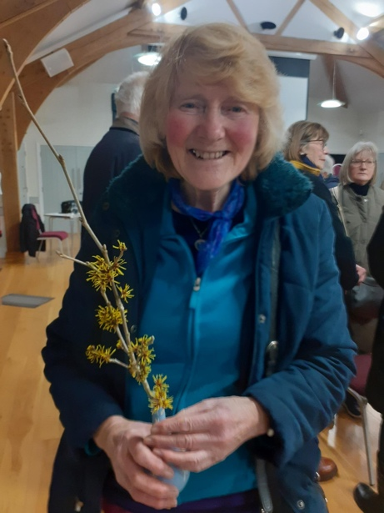
This is Dorothy Morris who won the competition in January with her lovely Witch Hazel.

Please bring a single cut bloom or spray from your garden, if you would like to join in The Flower of the Month
Competition. I appreciate there are few flowers at this time of the year but it’s amazing what you find when you look carefully! It doesn’t have to be exotic.

That’s all for this month. I look forward to seeing you at our meeting on 22nd – if you saw Mellie on Gardener’s World, you will know that we are in for an extremely knowledgeable and fun talk.

PS Don’t forget we are also on Facebook!

