
April 2023

Newsletter

South West Shropshire Gardening Club

I hope you all had a happy Easter. It was so lovely to see and feel the sun shining. I am enjoying trying to remember what all the little shoots appearing in my garden will look like when they grow up – working with a puppy last year was rather haphazard; he loved labels and kept running off with them so there are likely to be several surprises this year! My favourite plants in the garden at the moment are Erythronium Pagoda – nearly every year I seem to have a mental block trying to remember their name and muddling them with epimediums!
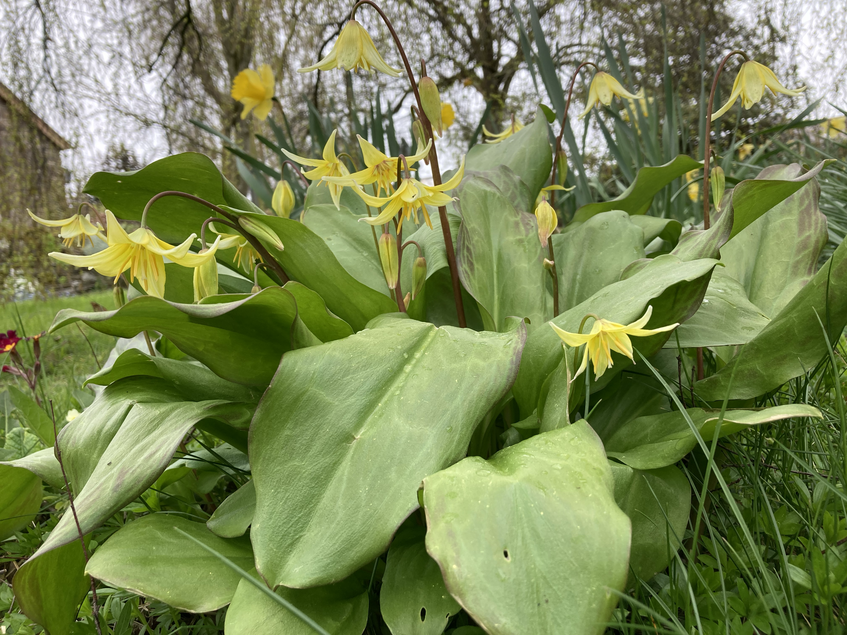

Teas
Many thanks to the Clunton team for manning the teas so efficiently last month, especially as we had such a full house! After this month, we have no more volunteers for May or July (we will be on our trip in June) so do please sign up on the rota as you come in, so we can continue our refreshments. Don’t worry if you are not sure of your commitments – we can always rearrange nearer the time if there is a problem. It only involves coming a few minutes early (about 6.45) to set out the crockery – the committee bring the supplies of tea, coffee, sugar, milk and biscuits. We will also put on the urn to heat up. We are finding that most people prefer to wash up by hand as they go along rather than using the dishwasher.

Pearl Garden

A big thank you to our faithful committee members who came for a weeding session of the Pearl Garden on the morning of April 11th. Thank goodness Sandra is a wily weatherwatcher and suggested the morning rather than the afternoon. We happily avoided the lashing rain and sleet in the afternoon. It was nice to catch up with a cuppa afterwards without having to stick to an agenda.

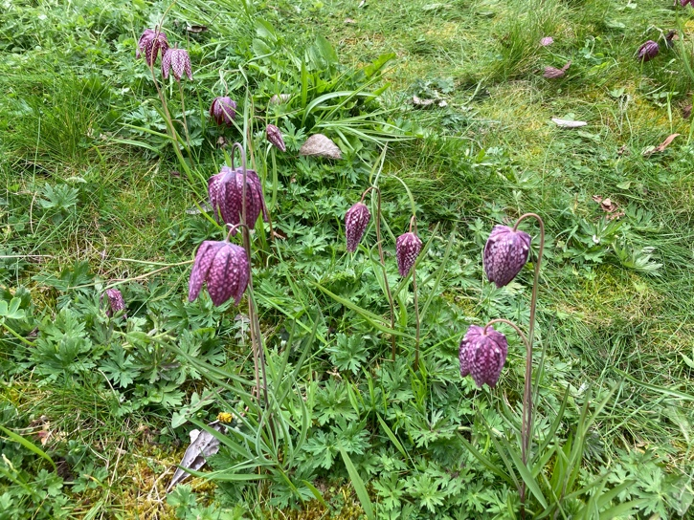
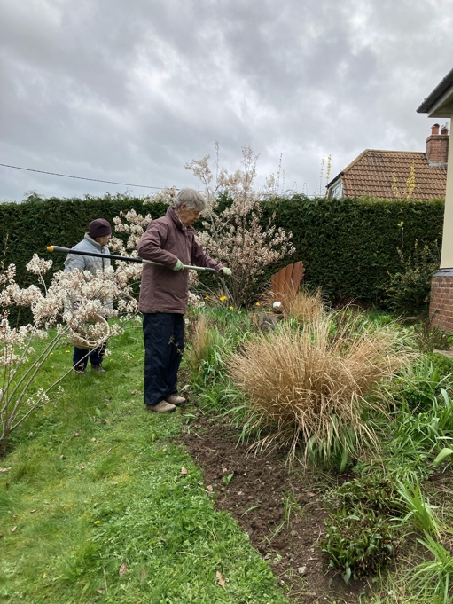

Newsletters
If you are having any problems receiving the newsletter, please let me know. We aim to send the notification that it is live about a week before the meeting so news is fresh in your mind. You will also be in the right place to look at the website – if you have any contributions or suggestions that may be of interest, please let me know.

NGS Shropshire and Powys
There are so many beautiful gardens to visit during May that to list them all here would take me ages! Do have a look on the website ngs.org.uk or collect a leaflet from the table at the back of the meeting. Feel free to send any photos for us to share on the website or tell us about your experiences.

Shropshire Historic Churches Trust
…also has four gardens open in May and there are other gardens to visit by private arrangement with the owners. Their website is www.shropshirehct.org.uk

Next meeting

Wednesday 26th April

The Gardens of the Arts and Crafts Movement – a talk by Richard Rallings

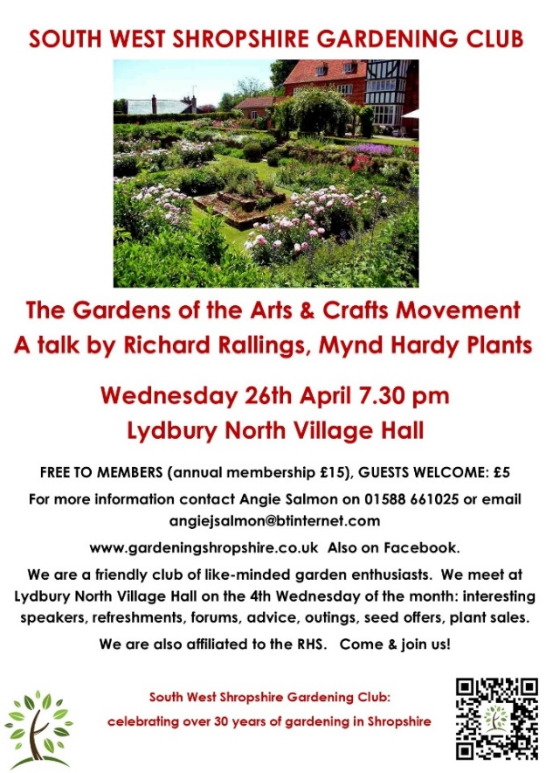

Richard and Jill Ralling run a plant nursery within the Victorian Walled Garden of Delbury Hall in Diddlebury, Shropshire. It is a perfect haven for both garden lovers and horticulturalists.

Richard will talk about The Gardens of the Arts and Crafts Movement examining the movement and its values of beauty, simplicity and craftsmanship during the late Victorian and Edwardian eras. The period is best known for its architecture, furniture and gardens, with an emphasis on the architectural works of Voysey, Scott and Lutyens, the artists Strachan, Allingham and Stannard and the garden designs of Jekyll, with examples of their works from around the country.

Membership
If you still need to update your membership, you can come along to a meeting at Lydbury North Village Hall and give your details and payment to our Membership Secretary Sandra Bailey, who sits at the door ready to greet everyone. Alternatively, you can pay by transfer, using the details below. Please ensure you email your name, address and phone number to Sandy.
Membership normally costs £15 to cover attendance to all our meetings for a year; early access to trips and events with subsidised tickets; seed offers and plant sales. We are also affiliated to the RHS. Such a bargain! From this month you can join at the reduced price of £10 – even more of a bargain!

Payment can be made with cash or cheque at our meetings or by transfer to:
South West Shropshire Gardening Club
sort code 20-53-22
account number 80754803.
Please add your name as reference and email sandy_burton@btinternet.com to let her know.

Summer trip to Hidcote Manor and Kiftsgate Court Gardens, Chipping Camden

Wednesday 21st June

National Trust members. Club members: £15. Guests: £20

Non NT members. Club members: £29. Guests: £34

Tickets are subsidised for members by the club and will be on sale at this month’s meeting and in May. The coach will leave the Community College in Bishops Castle at 9am and return between 6.30-7.00.

Hidcote is a world-famous Arts and Crafts-inspired Garden where colourful and intricately designed spaces are full of surprises. Many of the unusual plants were collected from around the world by the horticulturist Major Lawrence Johnston who created the garden.

Kiftsgate Court Garden has evolved organically under the care of three women, from the 1930s onwards. There are beautiful borders, wild areas, orchards, water features and woods to explore and enjoy.

Buy your tickets at meetings or from annie.frost@icloud.com.

RHS affiliation

The club is affiliated to the RHS. We receive the monthly magazine which can be borrowed, as well as back numbers. These are available from the table at the back of the hall where we display other items of interest and news.

Also, we have a discount card which can be used by up to two members of the club to gain 50% off entry to any RHS garden. Please ask me to borrow the card if you are planning a trip to an RHS Garden.

Plant Hunters’ Fairs

Rather than going to pricey garden centres with limited variety on offer, these fairs are well worth a visit (or several!)
The plant fairs bring together some of the best independent plant nurseries from across the country with a brilliant choice of plants to delight every gardener. The entrance charges on these special days are such good value, often up to half the standard garden entry price.

The fairs are also valuable fundraisers for our venues and every penny of the entrance fees goes to the venues to help them keep going after these tough times.

These fairs and gardens also make a great destination for group outings.

Plant Hunters’ Fairs for April 2023

(The Fairs for the remainder of the year are published on the Resources page on our website)

April
Saturday 1 Bodenham Arboretum, Kidderminster DY11 5TB 10am-4pm Free Entry to Fair
Sunday 2 Ness Botanic Gardens, Wirral, CH64 4AY 10am-4pm Plant Fair £1.00
Good Friday 7 Whittington Castle, Oswestry, SY11 4DF 10am-4pm Plant Fair & Castle Grounds Free Entry (P&D Parking)
Easter Sunday - Monday 9 - 10 Dorothy Clive Garden, Market Drayton TF9 4EU 10am-5pm Gardens & Fair £5.00
Sunday 16 Middleton Hall, Tamworth B78 2AE 10am-4pm Gardens & Fair £3.50 TICKET REQUIRED
Saturday 22 1620s House, Donington Le Heath, LE67 2FW 10am-4pm Gardens & Fair £1.00 TICKET REQUIRED
Sunday 23 Cholmondeley Castle, Malpas, SY14 8AH 10am-5pm Gardens & Fair £5.00
Sunday - Monday 30 April - 1 May Weston Park, Shifnal TF11 8LE 10am-4pm Gardens & Fair £4.00 TICKET REQUIRED*
PLEASE always check event status before travelling at www.planthuntersfairs.co.uk
* For Weston Park advance purchase tickets are at the special discounted price of £4.00 (plus small booking fee). Tickets not on sale after 9am on the day of the fair. Without a ticket, venue entry price of £8.00 applies.

For more information contact janet@planthuntersfairs.co.uk

Spring Gardening Tips ( from a knowledgeable and very experienced member of our club!)

Spring Into Action
Seasonal tips from one of our members
- Recent heavy rains will have depleted soil nitrogen
Scatter organic fertiliser e.g. chicken pellets, around
shrubs and hardy perennials, and top dress any
over-wintered outdoor plants in containers/pots.
- Time to feed and mulch roses to suppress weeds
and retain moisture. Work any feed in lightly with
a fork to aerate the soil.
- Lightly trim shrubby perennials cutting back to
healthy outward facing green buds, and cutting out
brown decaying or diseased shoots. Mulch around
the base to encourage new growth.
- April showers (sorry, downpours!) will have acidified soils. If growing brassicas, lime the beds
to correct the low pH, whilst also reducing the
incidence of club root. Application rate around
2oz/60g per square metre.
- Prune HT roses. Cut back any shoots with dieback
to healthy tissue and other shoots to a swelling and
outward facing bud to promote air flow in centre of
the bush.
- Sow annuals (when soil has warmed up) and in the spot where they are to flower. In the greenhouse
or under cover, sow in cell trays to avoid any root
disturbance when later transplanting.
- Check over wintered plants in pots for vine weevil.
The creamy orange headed C - shaped grubs (1 cm)
should be visible if you lift plant out of its pot. To
remedy wash roots of soil, repot in fresh compost.
Happy Gardening

Flower of the Month Competition

Judith Bowen won Flower of the Month in March with her lovely cultivar of a British native Lady’s Smock.

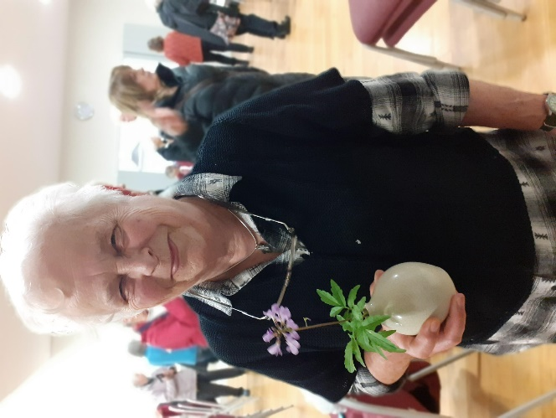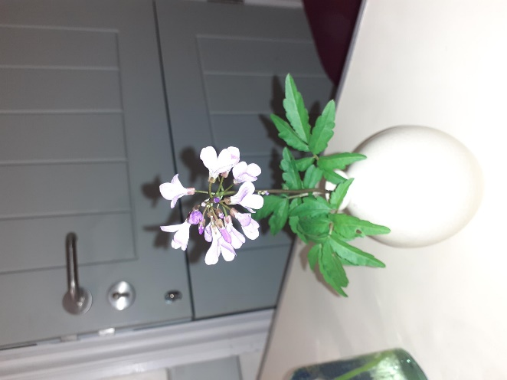

Please bring a single cut bloom or spray from your garden, if you would like to join in The Flower of the Month
Competition. Our choice of blooms is happily increasing and it is always interesting to see what people bring from their gardens.

Apologies in advance because next month, the newsletter will either be early or a little later than usual. Devoted as I am to the club, I draw the line at poring over my iPad while away on holiday!

I look forward to seeing you at our meeting on the 26th.

Angie Salmon
Chair

PS Don’t forget we are also on Facebook!

